THANKSGIVING
WHERE ARE WE NOW?

MATERIALISM is a four letter word. The biggest obstacle we face in our quest to be with God is our desire to hold onto our material possessions. The phrase “you can’t take it with you” seems to fall on deaf ears for many of us. If we can’t take it with us we are sure going to try to hang onto all of it while we are here. God has exhorted us throughout the ages to give back to Him from all that He has given us. The large number of times that this message is given in both the Old and New Testaments is proof of God’s knowledge that this is the biggest hurtle we face in coming to Him.

A rare example of Jesus rejecting an individual who is asking to be included as a disciple is the story of the young man who was unable to give up his worldly possessions and follow Christ. When the young man could not turn his back on his worldly possessions but instead turned and walked away from Jesus, Jesus turned his back on him by saying “ it is easier for a camel to pass through the eye of a needle, than for a rich man to enter the kingdom of heaven”. This is a very powerful message that Jesus is giving us. Do we dare risk our heavenly inheritance in order to hang onto earthly possessions. Our salvation is that Jesus did not say it is impossible for a rich man to reach heaven, only difficult. However, if the young man does not take some positive steps towards sharing his riches, it could in fact be impossible. The image of Jesus turning his back on me because of my material greed is the scariest thing I can imagine. Think about it.

Where does this lead us as a parish in our desire to become true disciples of Christ? A first step would be an examination of where we are now. In other words where are we in our own individual obligation to give back to God in Thanksgiving. An analysis of our parish family giving reveals the following:

- 9% of registered families (54 families) are contributing 49% of the
total income of the parish. They are giving more than $20 per week.

- 26% of registered families (154 families) are contributing 41% of the
parish income. This group is giving between $5 and $20 per week.

- 65% of registered families (386 families) contribute less than 10% of
the parish income and are giving less than $5 per week. The average weekly contribution for this group is $2.50.

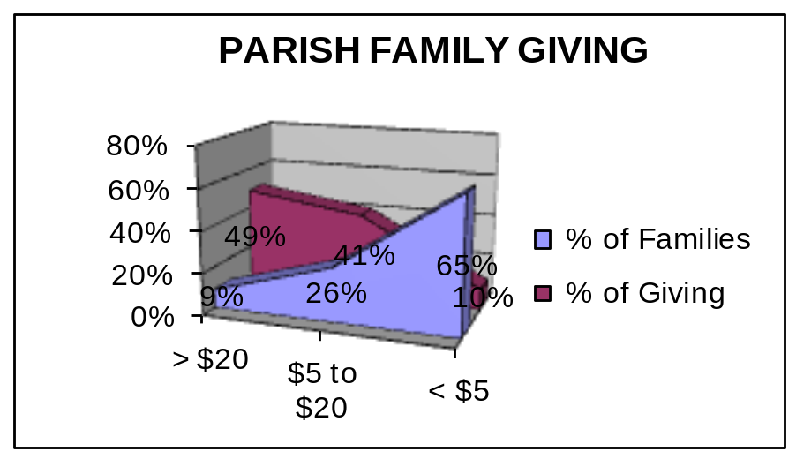

How does this weekly giving translate into tithing percentages at various income levels?

Weekly Annual Gross Income
Contribution $40,000 $50,000 $75,000

$5.00 .65% .6% .4%
$10.00 1.3% 1.0% .7%
$15.00 2.0% 1.6% 1.0%
$20.00 2.6% 2.1% 1.4%
$30.00 3.9% 3.1% 2.1%
$40.00 5.2% 4.2% 2.8%
$50.00 5.6% 5.2% 3.5%

Where do you fall in the above two analysis’? Are you in the 9%, 26% or 65% group? Are you tithing at less than .4% to .65%? Remember the definition of tithe is “a tenth part [10.0%] paid in kind or money”. Are you making a real effort to give thanks to God for what he has given you? I pray that none of us has that vision in our mind of Jesus turning his back and walking away from us due to our desire to hold onto our earthly possessions. This is a wake up call for all of us.

As Jesus would say, “In the matter of Thanksgiving, are you my disciple?”

