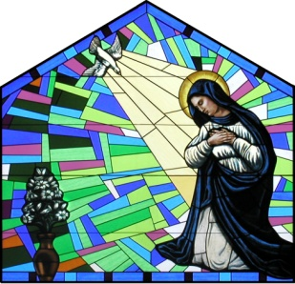
Saint Mary Catholic Church
1749 Racine Ave, N.E.
Solon, IA 52333
Phone: (319) 624-2228; Fax: (319) 624-3564
Fr Vrba’s email: VRBAJ@DIODAV.ORG

Greetings!

Thank you for your interest in using Electronic Funds Transfer for your financial support of Saint Mary’s.

Benefits to you:
- EFT is Green – it is an ECO-friendly way of giving
- Saves you time and money – fewer checks to write
- Helps you carry out your commitment in a timely manner, even when you are out of town
- It is easy to sign up, it is easy to change, it is easy to cancel
- You don’t have to change your present banking relationship
- There is no service charge to you.
- You will have an accurate monthly record of your contributions from your financial institution.

Benefits to Saint Mary’s:
- Provides a more predictable cash flow for better planning
- Saves time and money associated with processing check and cash donations manually
- Helps the efficiency and accuracy of the parish database
- Secure and easy cash maintenance

To sign up, follow these simple steps:
- Fill out the special authorization form on the reverse side. Attach a voided check or a savings account deposit slip if you designate that account.
- You may transfer funds to Saint Mary’s twelve or twenty-four times a year.
- After you submit your authorization, allow two weeks for the transfers to begin
- You may increase, decrease or terminate your agreement at any time by notifying Saint Mary’s, allowing reasonable time for the bank to act on your request.
- You will still receive your monthly envelope mailing for special purposes (eg. Holydays, Building Fund, Catholic Messenger, etc). And if you like, you can always put in your empty Sunday envelope in the basket and write “EFT” on the front side.

If you have further questions about Electronic Funds Transfer, please call me or Donna at the church office.

Thank you very much for your continued support of Saint Mary Church!

Sincerely yours,

Very Rev. James J. Vrba, VF
Please return this form to the parish office either by mail or via the collection basket.

